**Experiment 10:Creating a SNS with Email and SMS notificationss**

SIMPLE NOTIFICATION CREATION:

1.Create a SNS service:

2.Give a topic name ->Next ->Standard ->create topic

3.Select subscription for email:

Give the email id as endpoint and save the changes.

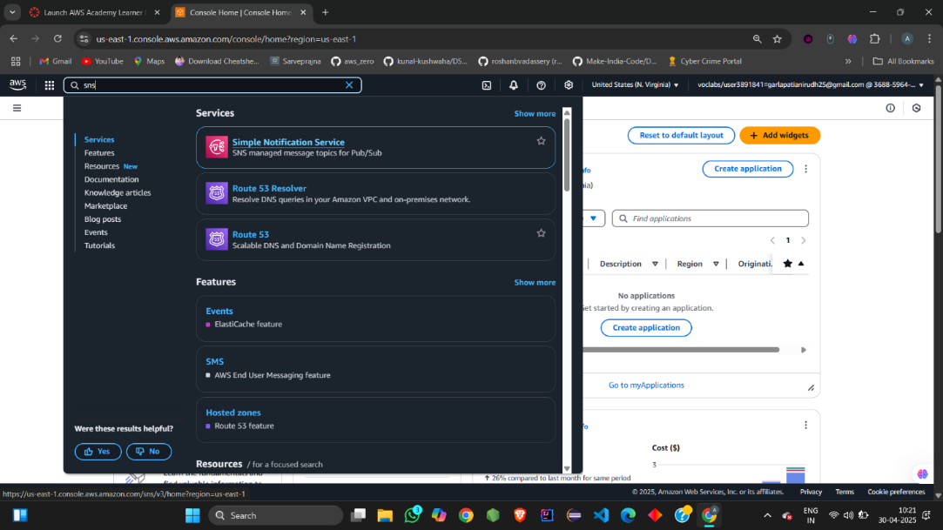

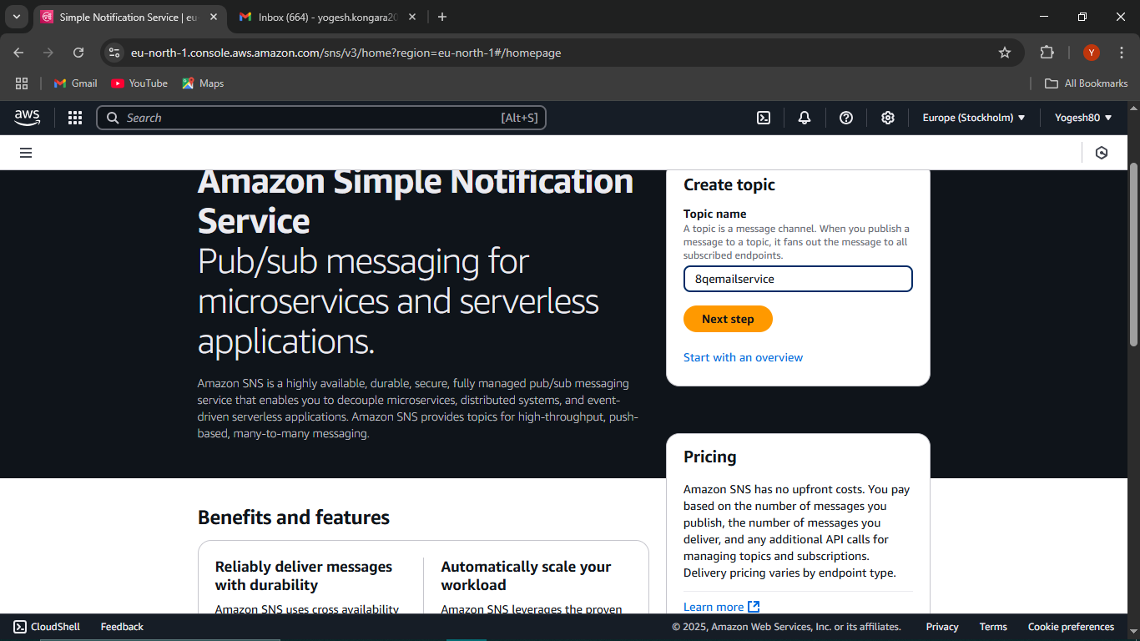

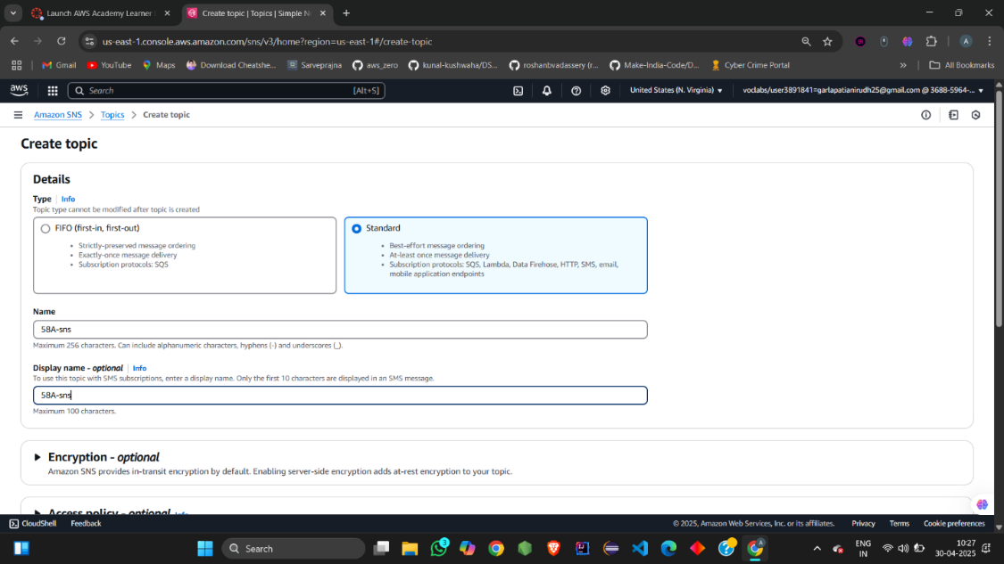

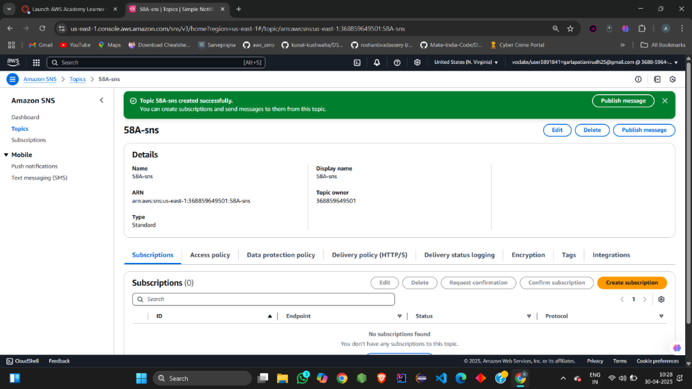

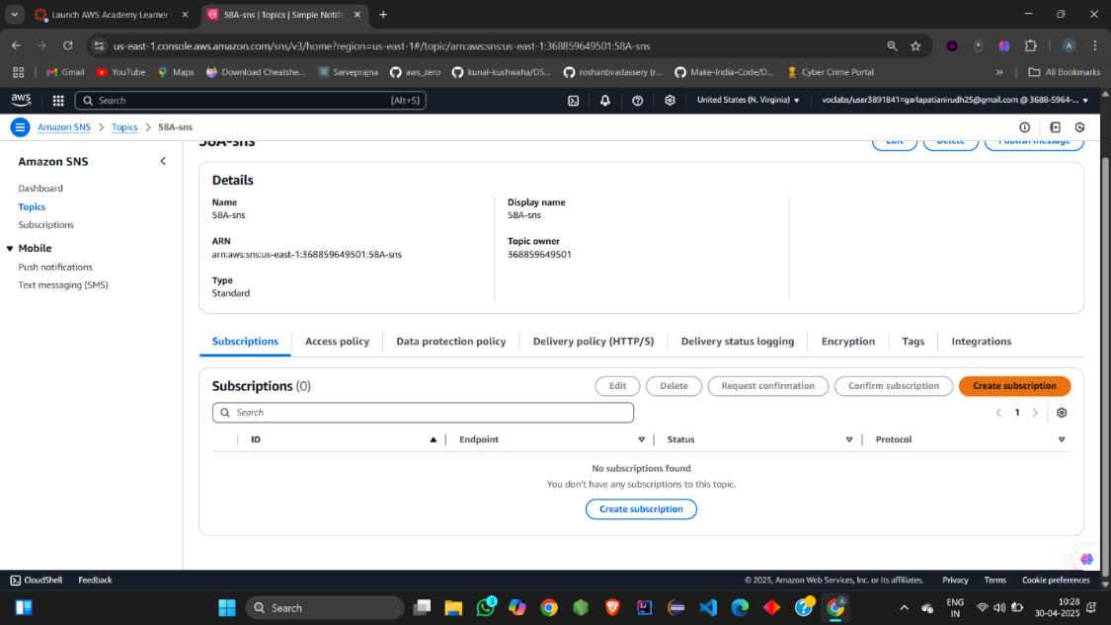

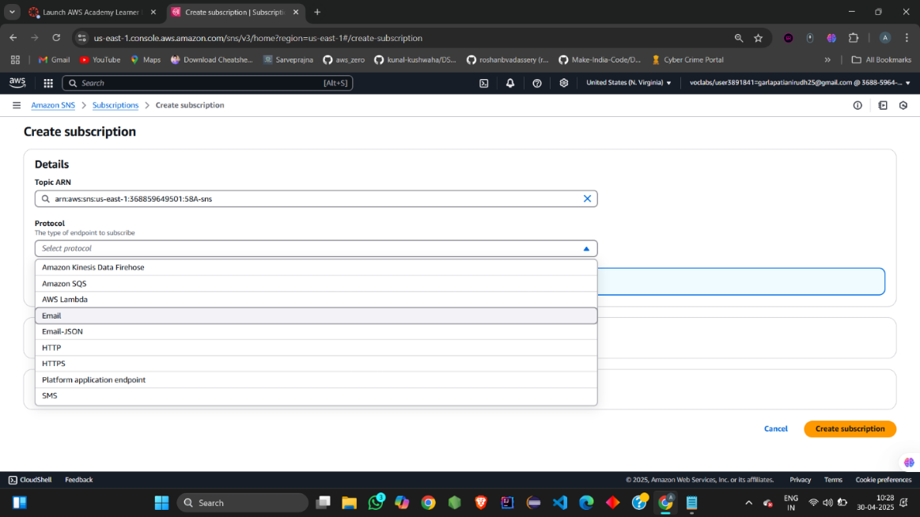

Confirm the subscription the email :

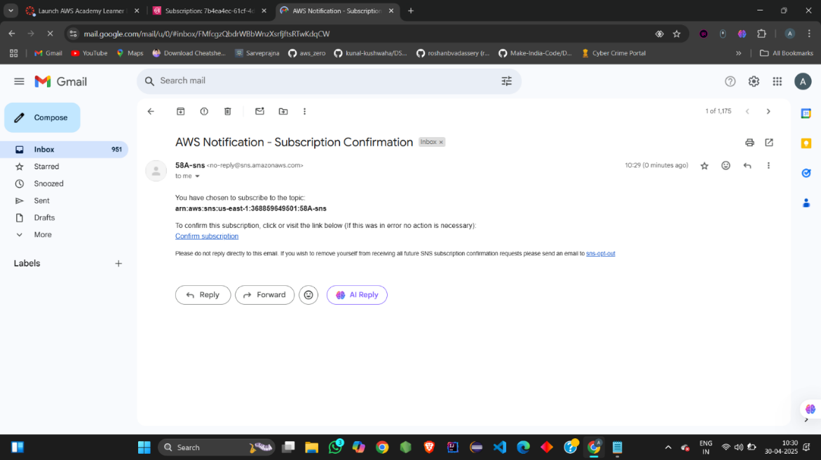

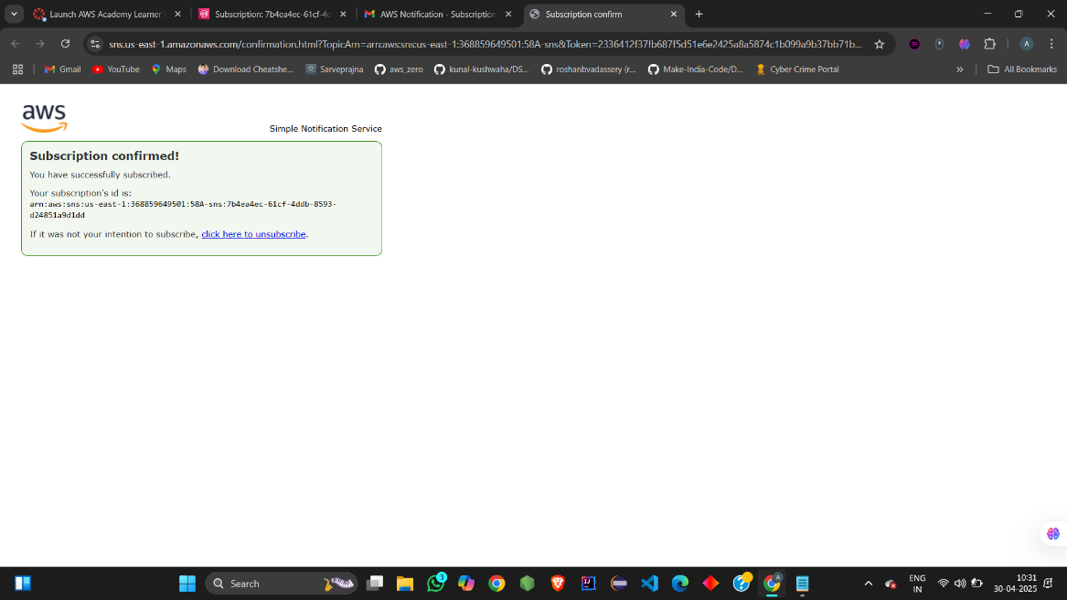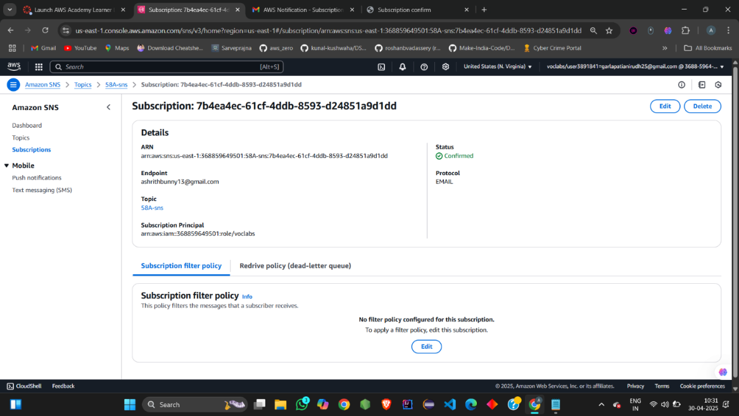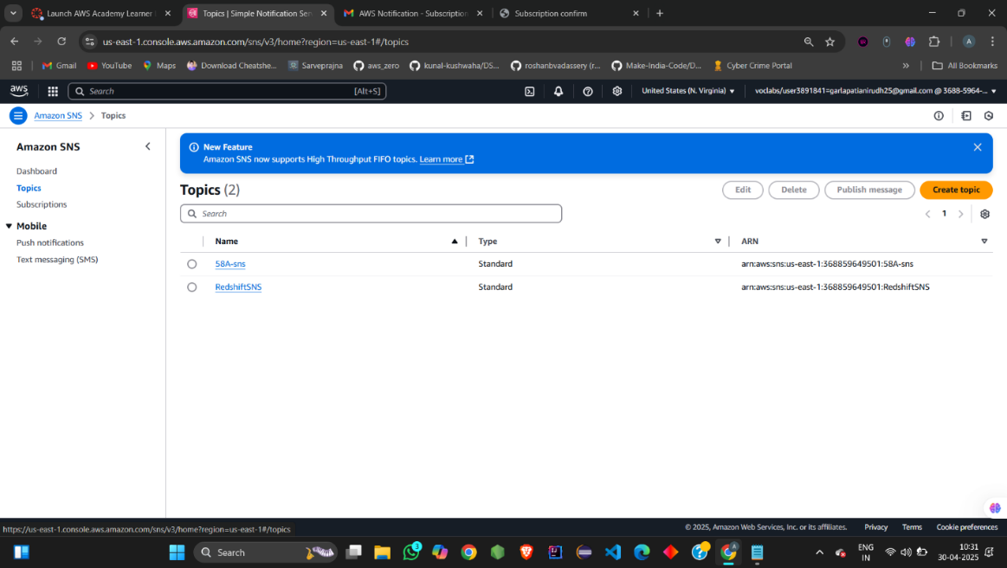

Publish the message ,give the subject and then type the message body and then publish the message:

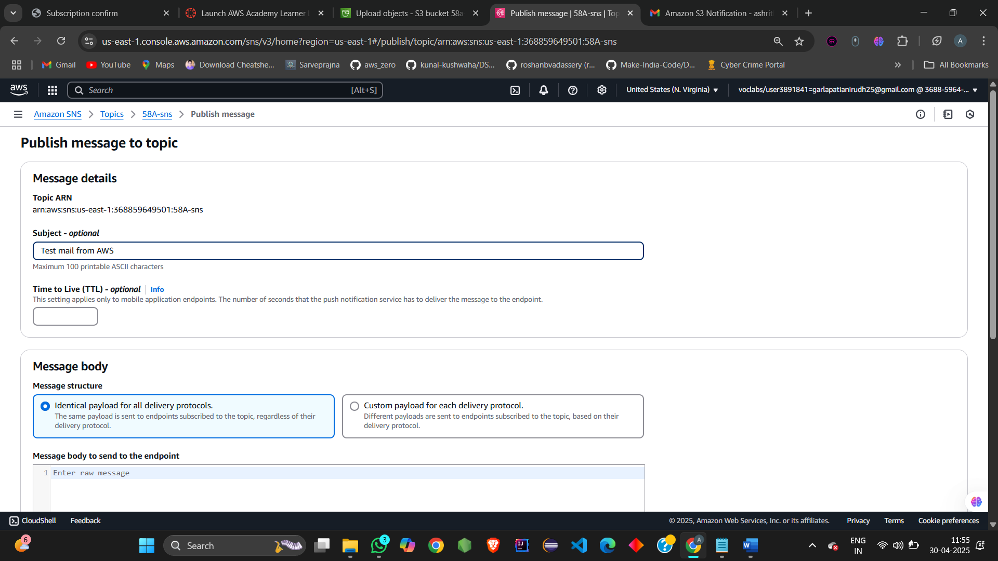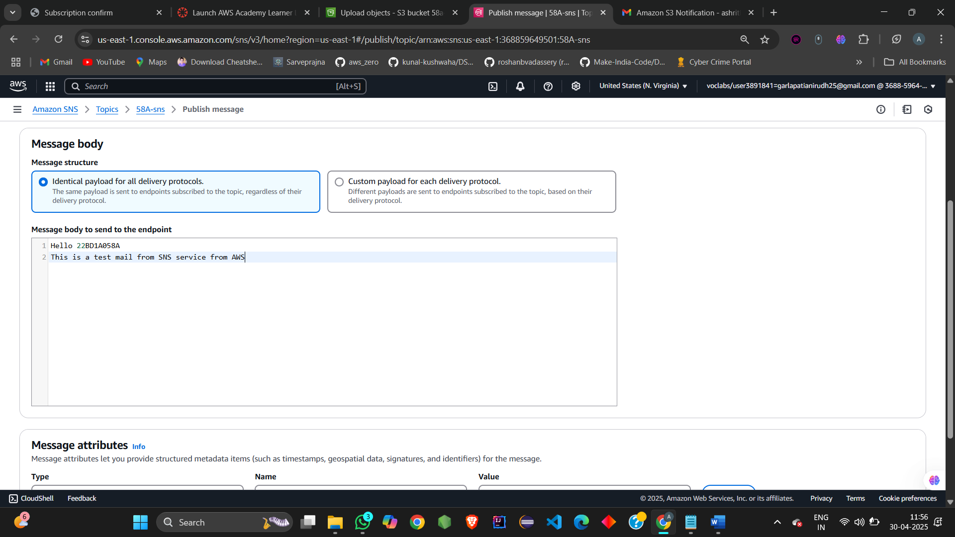

Successful receiving of email verifies creation of SNS service using email:

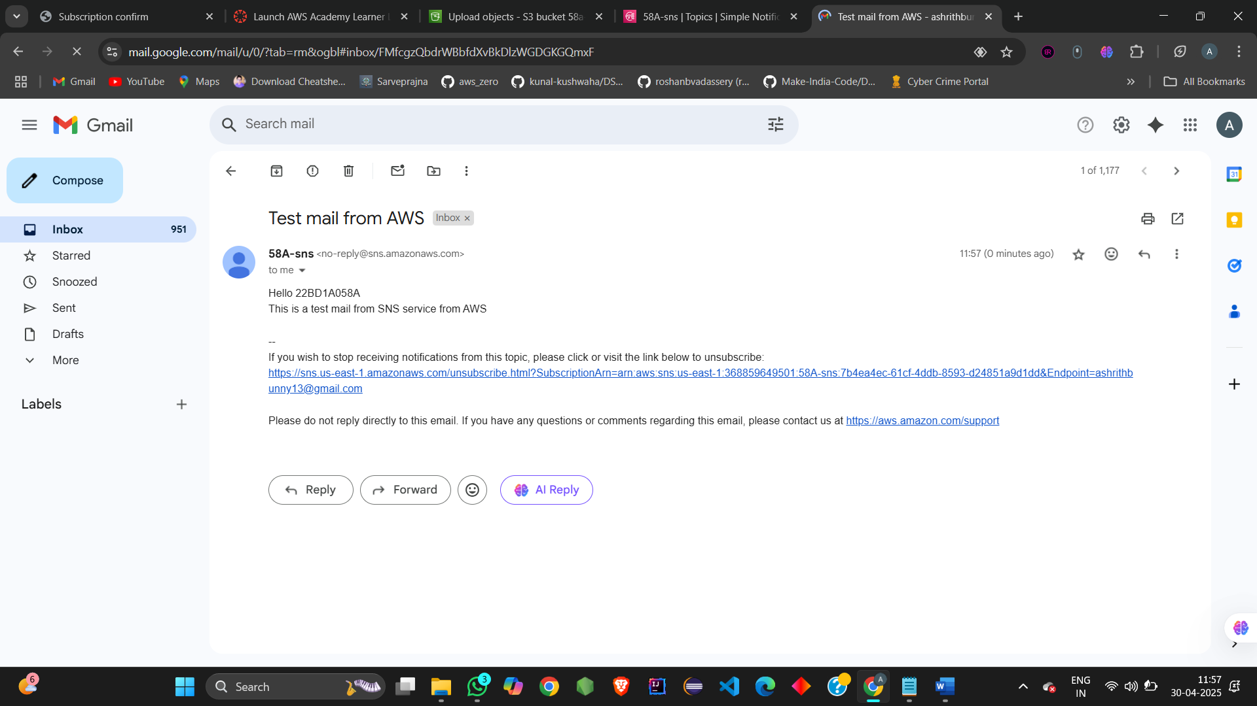

SNS using text message(SMS):

Click on text message.

Publish message->Add phone number->Verify the mobile number

Type the ,message that is to be sent and click on publish message.

You will receive a message on your mobile number.

This verifies SNS service for text message using SNS.

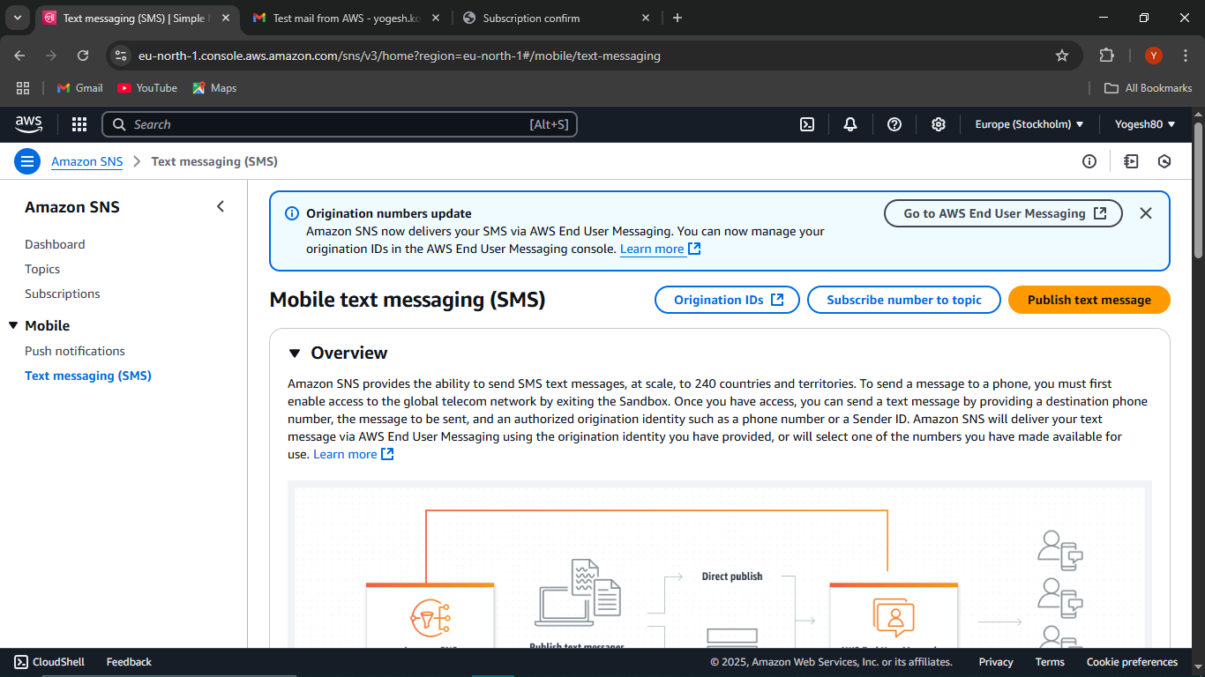

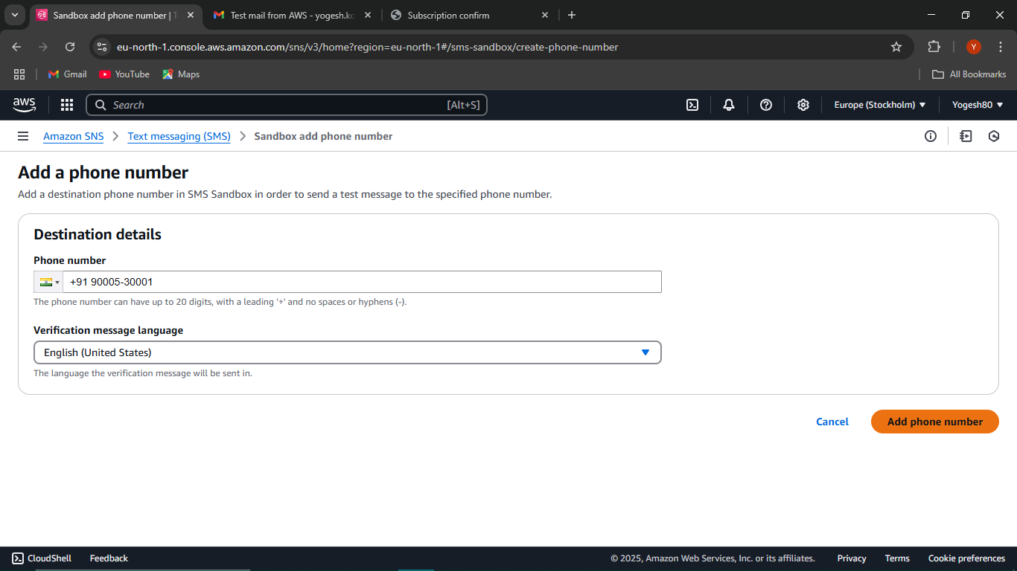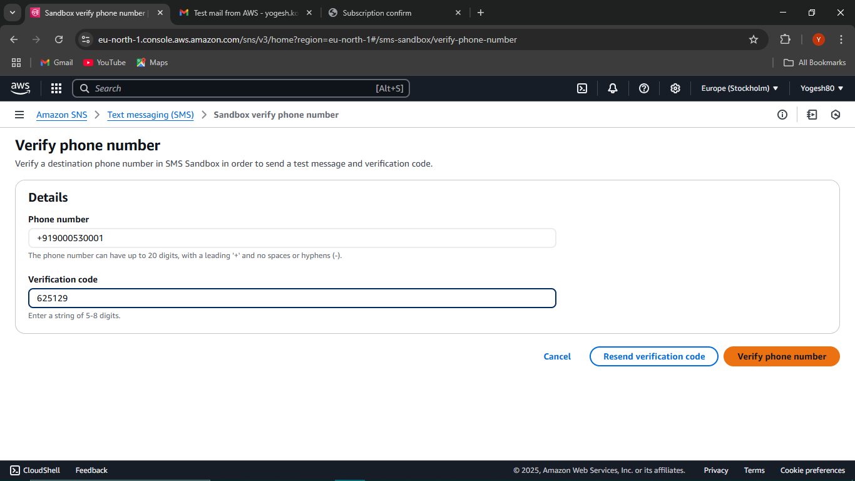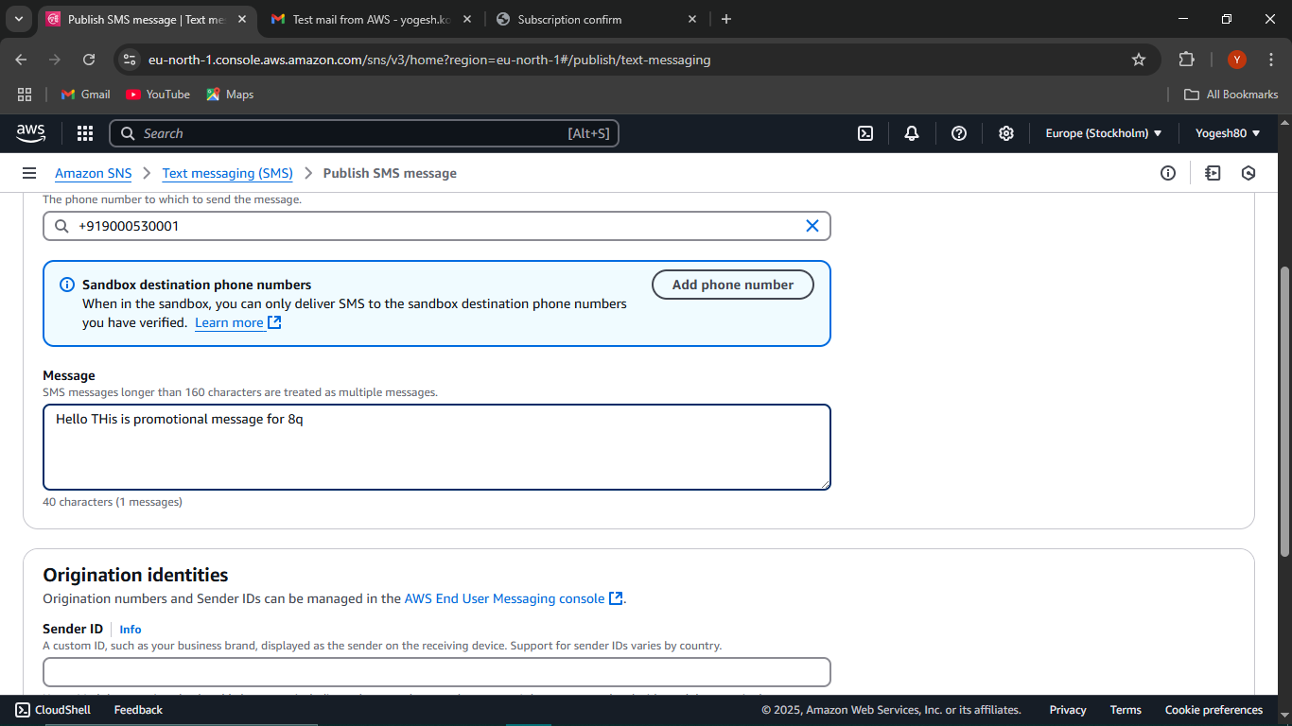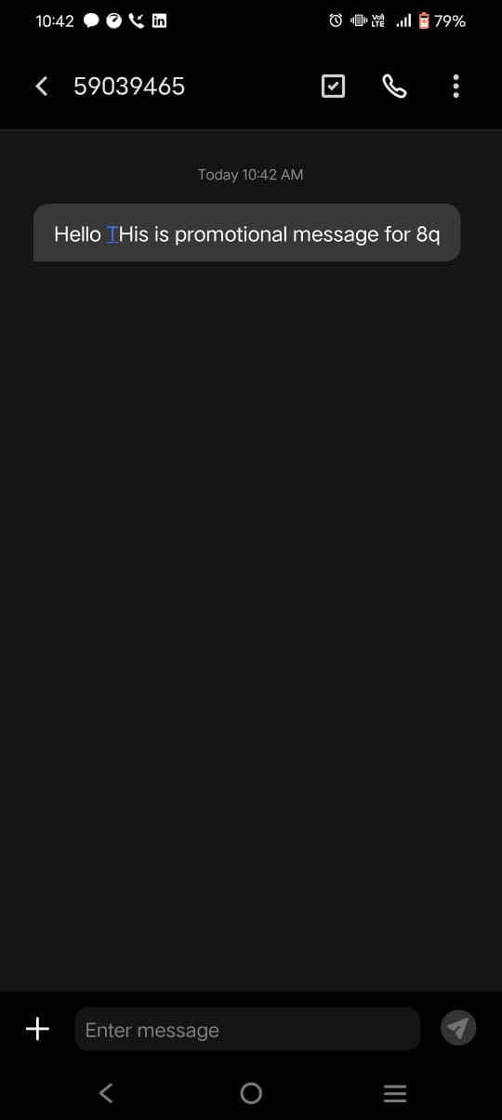

SNS for S3 bucket:

Create a SNS service by creating a topic and then add the subscription for the topic by linking the mail:

Now Create a S3 bucket ->Go to properties->Create event notification

Now fill the event name and select the event types and then destination as SNS and select the SNS topic created and subscribed earlier.

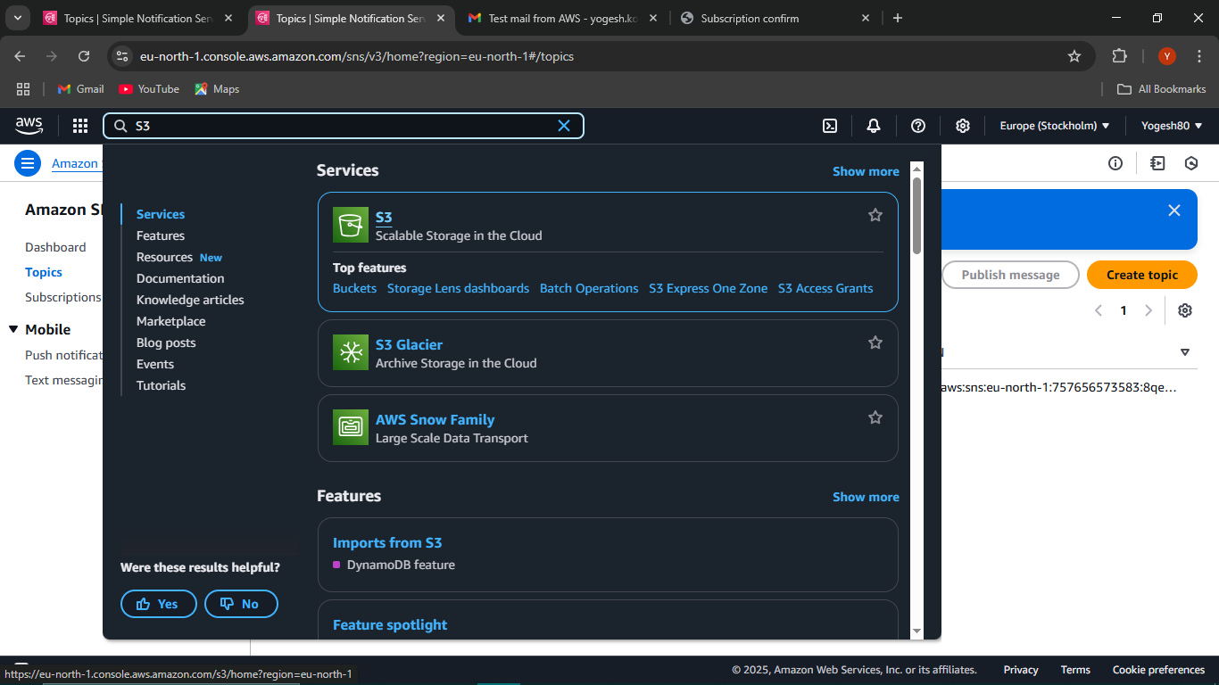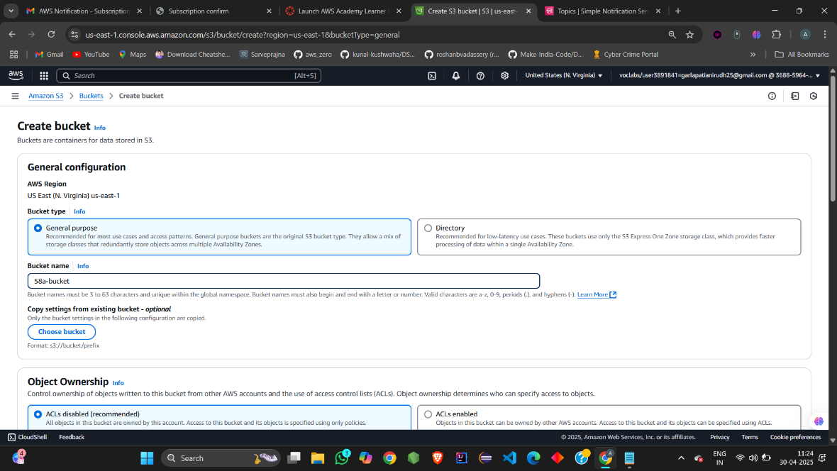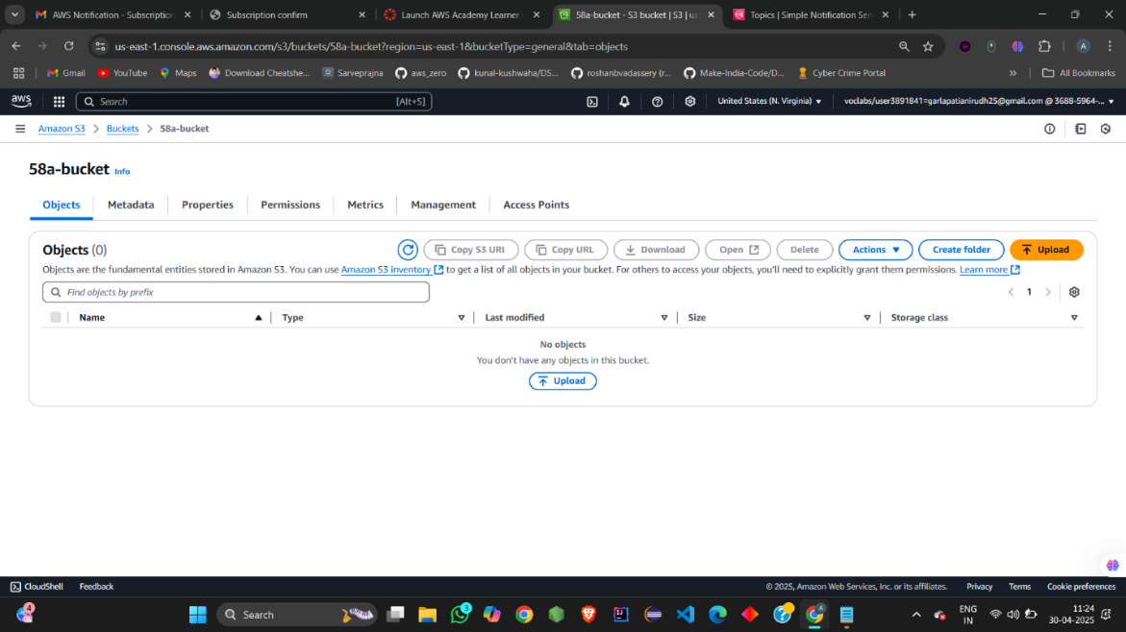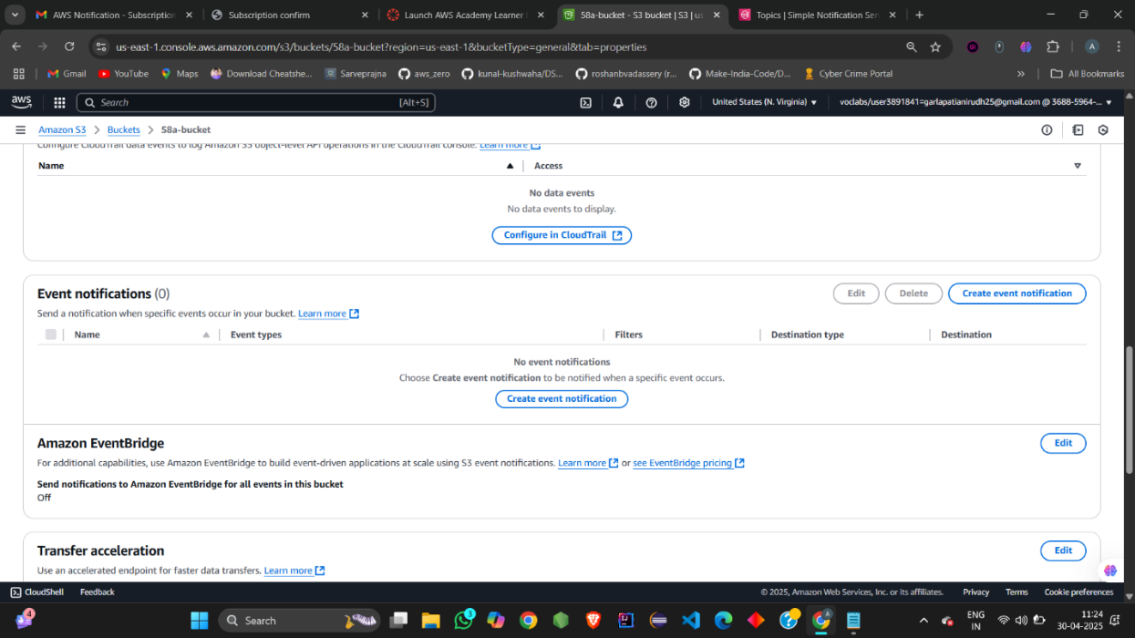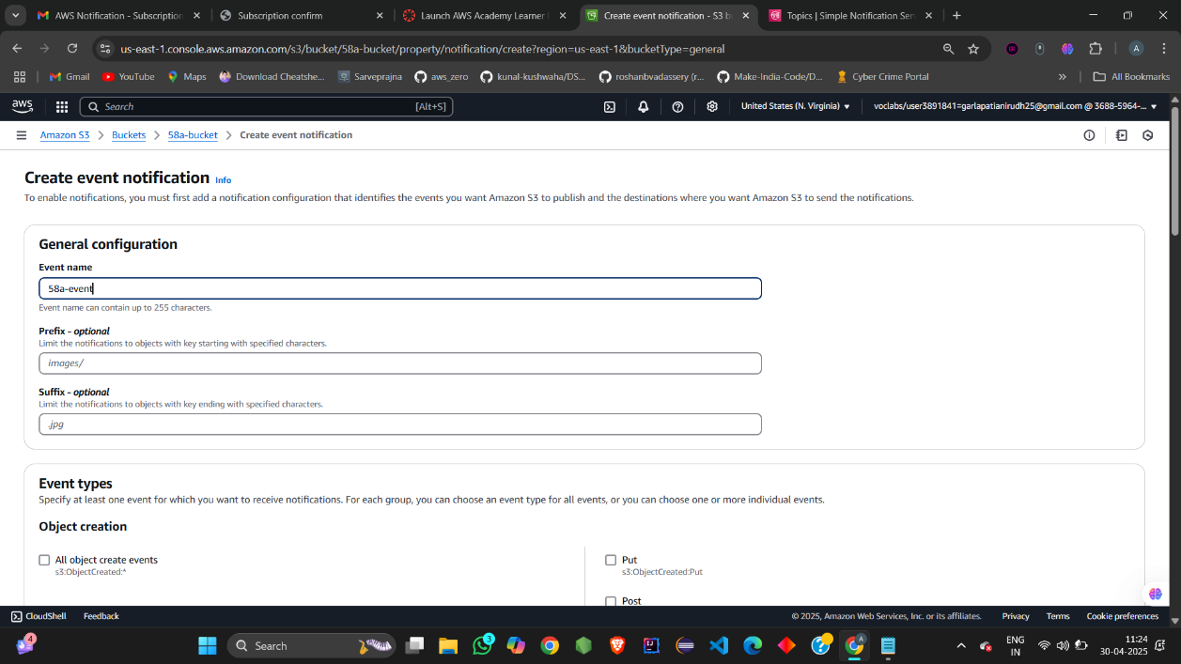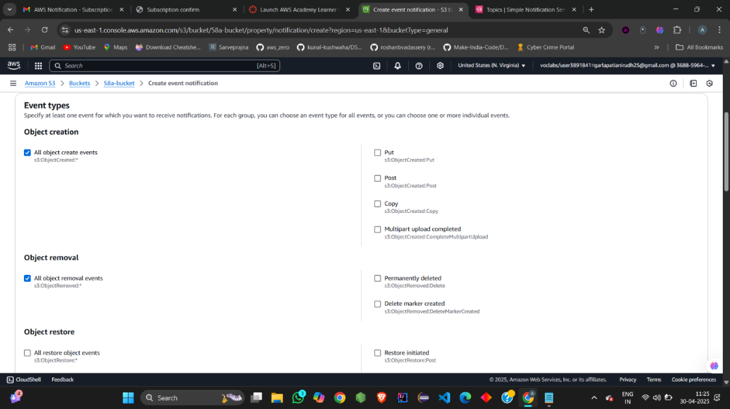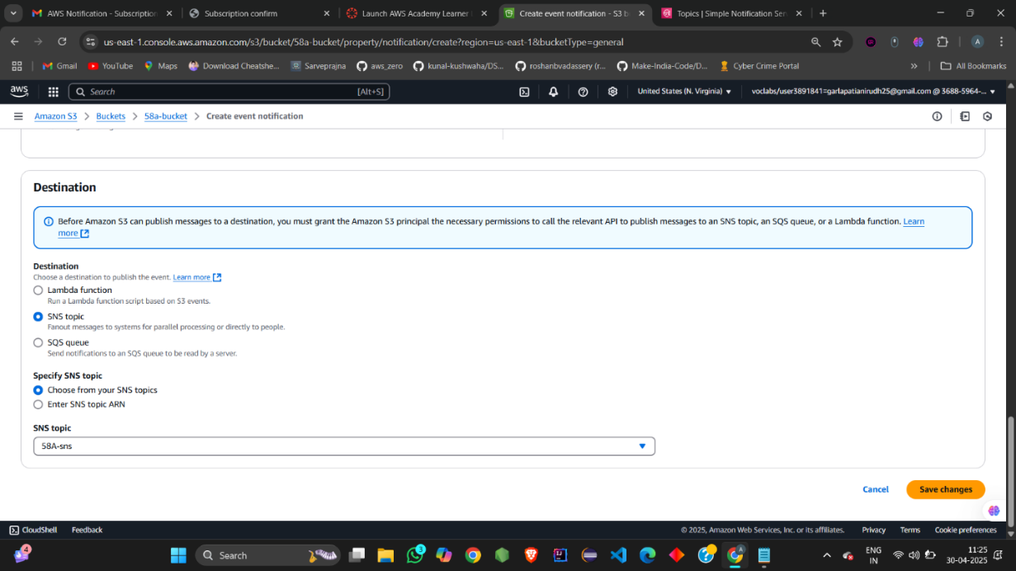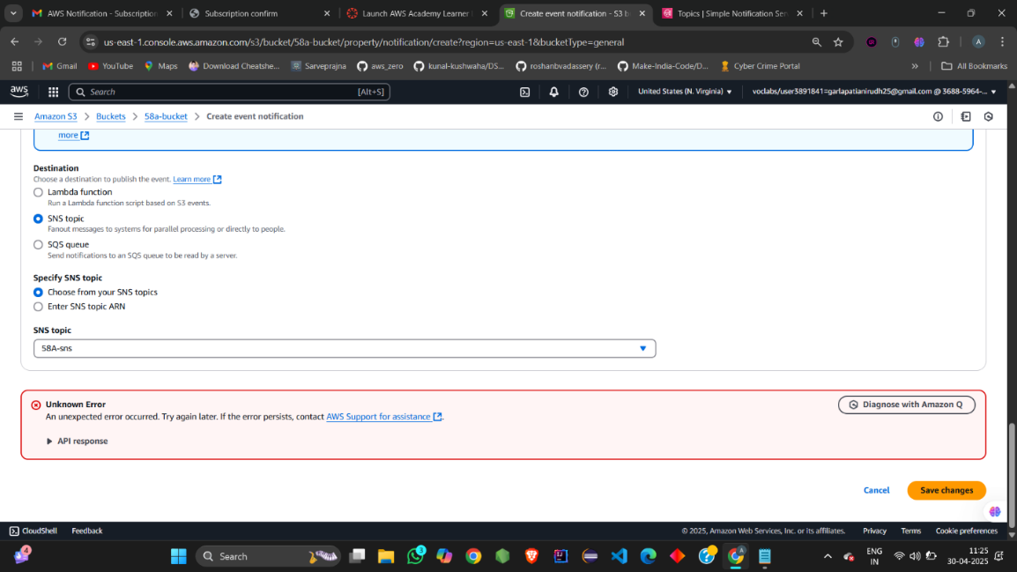

Save the changes ,it throws an error as SNS is not configured. Now go back to SNS service and select the topic created and then edit access policy:

{

"Version": "2012-10-17",

"Id": "example-ID",

"Statement": [

{

"Sid": "Example SNS topic policy",

"Effect": "Allow",

"Principal": {

"Service": "s3.amazonaws.com"

},

"Action": [

"SNS:Publish"

],

"Resource": "SNS-topic-ARN",

"Condition": {

"ArnLike": {

"aws:SourceArn": "arn:aws:s3:::amzn-s3-demo-bucket"

},

"StringEquals": {

"aws:SourceAccount": "bucket-owner-account-id"

}

}

}

]

}

Change the SNS arn of topic and bucket arn and then the account id:

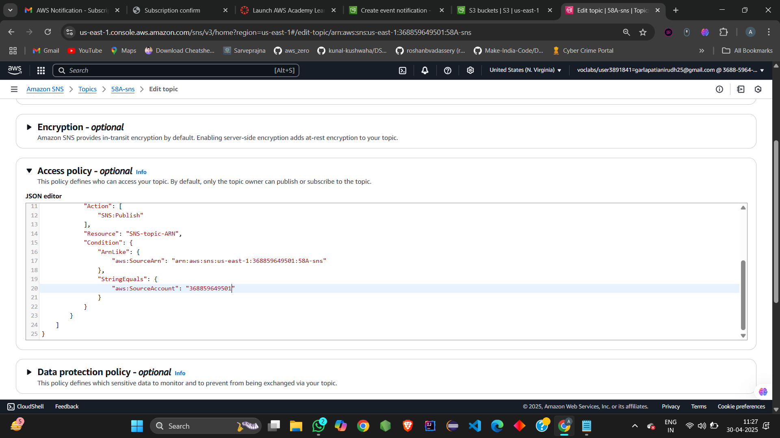

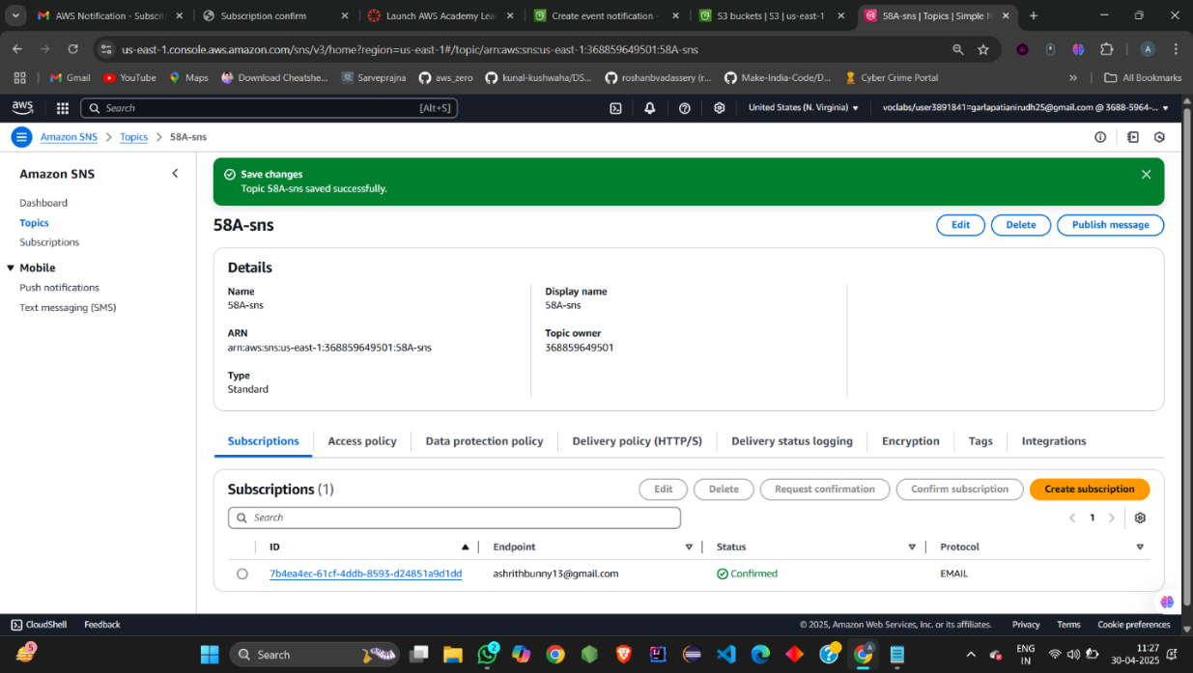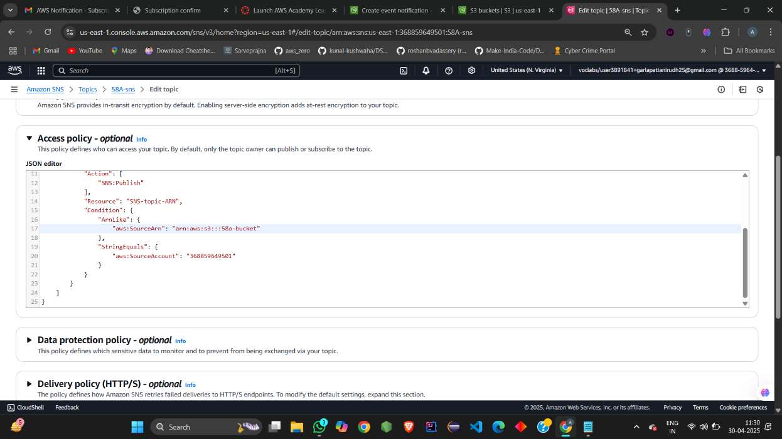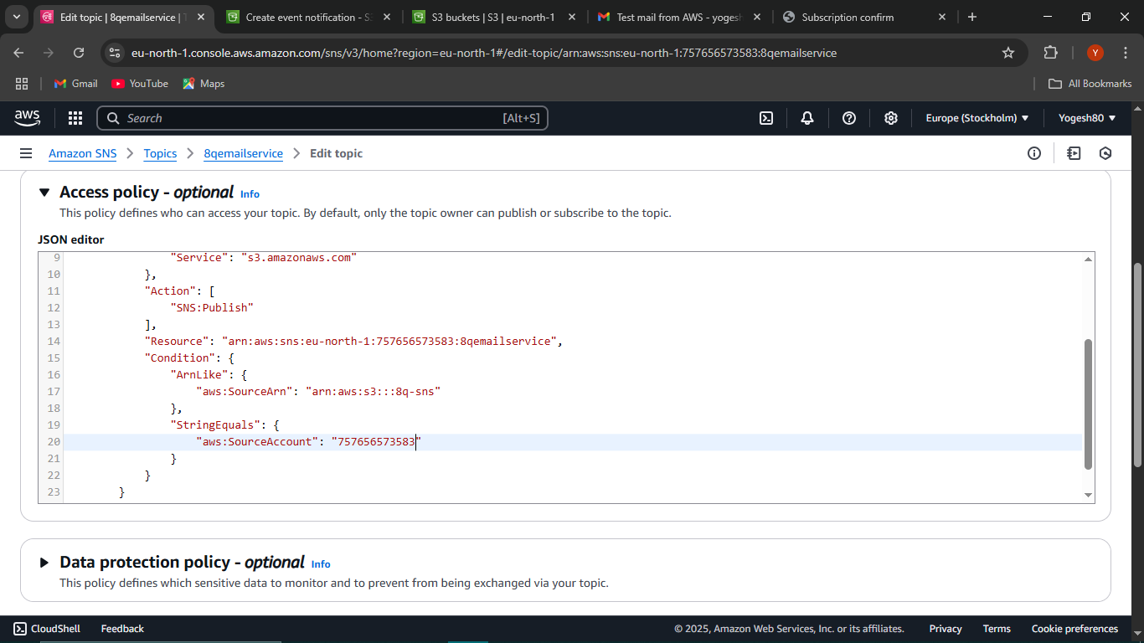

Go back to S3 bucket and save the changes , now events are successfully created.

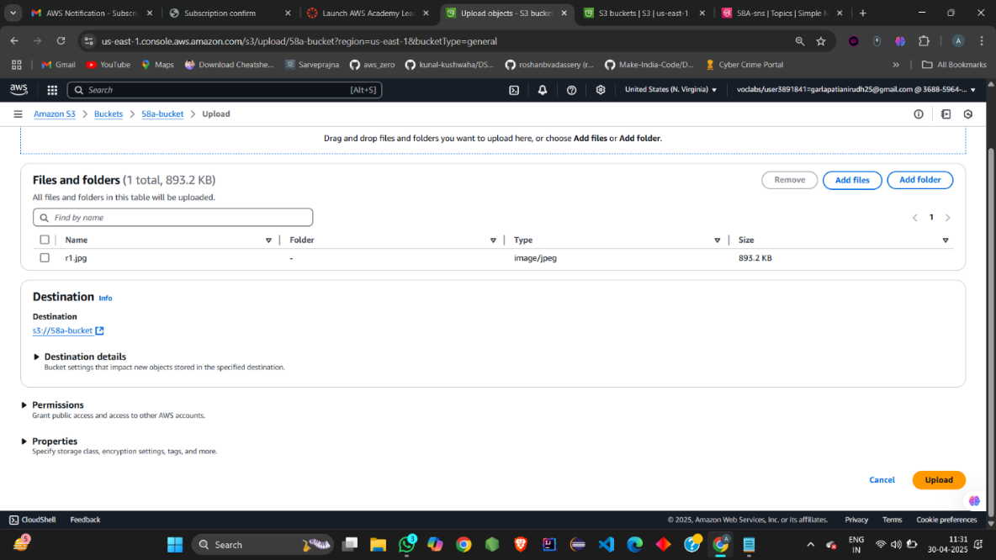

Now upload the object in the bucket that is configured with the SNS and check your mail for the notification:

Successful email notification withy meta data of the object uploaded is received on mail

